PHUONG KY PRIMARY SCHOOL  Name:______________________.  Class : 5____ |  |  |  | THE FIRST TERM TEST  ENGLISH GRADE 5  School Year : 2022 - 2023  Time : 40 minutes  Date: ........................
 | Teacher 1 |  |  |  | Teacher 2
 | Marks |  |  |  |  |  | Comments
 | Listening | Reading and writing | Speaking |  |  | Total
PART I. LISTENING (3 pts)
Task 1. Listen and match. There is one example (0). (1pt)
A.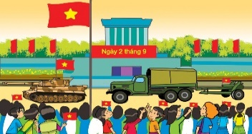
B.
C.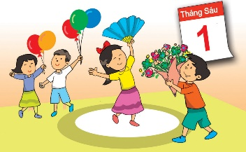
D.
E.
Task 2. Listen and tick A, B or C. There is one example. (1pt)
Example:
 | Yes, I can. | Yes, I do. | Yes, I am.
 | A. | B. | C.
1. | I can read Aladdin and the Magic Lamp. | I’m reading Aladdin and the Magic Lamp. | I like Aladdin and the Magic Lamp.
 | A. | B. | C.
2. | It’s Aladdin. | His name is Aladdin. | He’s the main character.
 | A. | B. | C.
3. | He’s clever. | He’s a boy. | He likes stories.
 | A. | B. | C.
4. | I don’t like stories. | It’s about Snow White and the Seven Dwarfs. | The Fox and the Crow.
 | A. | B. | C.
Task 3. Listen and tick the correct pictures. There is one example. (1pt)
Example: What animals were in the cage?
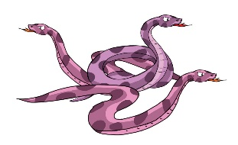 | 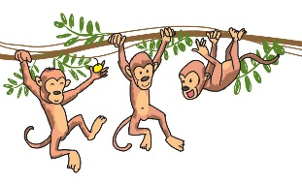 | 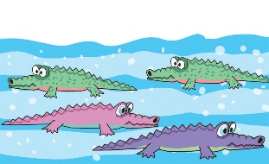
A. | B. | C.
1. What animals did Tom see?
A. | B. | C.

2. What did tigers do when he was at their cage?
A. | B. | C.

3. What did the baby elephants do?
A. | B. | C.

4. What animals did they talk about?
A. | B. | C.

PART II. READING AND WRITING(5pts)
Task 1. Look and write the correct words. There is one example.(1pt)
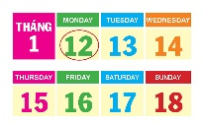 | 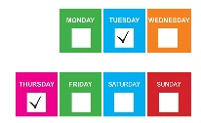 | 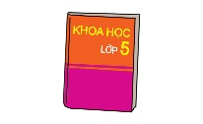 | 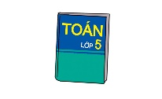 | 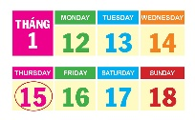
Monday | twice | Science | Maths | Thursday

Example: It is the first working day of the week. | Monday
1. It’s the day before Friday. | _________
2. You learn about numbers and shapes in this subject. | _________
3. It’s the different way to say ‘two times’. | _________
4. You learn about plants and animals in this subject. | _________

Task 2. Read and tick True or False. There is one example (0). 1(pt)
After school, Bill often stays at home and reads books. He likes reading comic books. His favourite story is Doraemon. It is the name of a magic cat, the main character of the story. The cat has a lot of magical things in its pocket. It comes to Japan from the future to help Nobita and his friends. Bill likes the story very much because the magic cat is friendly and very intelligent.
 | True | False
0. After school, Bill often reads books in the library. |  | ✔
1. He doesn’t like reading comic books.
2. A magic cat is the main character of the story Doraemon.
3. The cat has a lot of magical things.
4. The cat comes from Japan.
Task 3. Look and read. Fill each gap with one word from the box. Write the word next to the number. There is one word that you do not need. There is one example (0). (1pt)
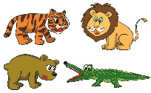 | 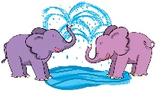 | 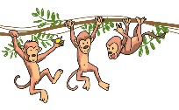 | 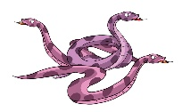 | 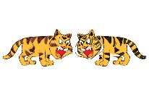 | 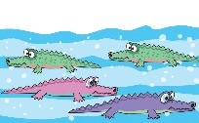
animals | sprayed | monkeys | pythons | roared | crocodiles

Last Sunday, my class went to the zoo. It was a sunny day. We saw a lot of wild (0) animals. Big tigers (1)________ loudly. A baby elephant (2)________ water with its trunk. It looked happy. Three (3) ________ were so noisy on the tree. The (4) ________ moved so quietly. In the end, we had a lot of fun at the penguin show. It was a great trip to the zoo.
Task 4. Look at the pictures. Read and write one word for each gap. There is one example.(1pt)
Example:
We visited London Zoo last week.

1. | A _______________ danced beautifully.

2. | A ______________ ate a bamboo tree.

3. | Two ________________ roared loudly.

4. | I took photos of some __________ for my Science project.

Task 5. Order the words. There is one example.(1pt)

Example: | like / in / I / the / reading / library / books  I like reading books in the library.

1. | you / what / reading / are/?  ……………………………………………............................................?

2. | lessons /How/do/ many/ today/ have /you / ?  ……………………………………………............................................?

3. | did / go/ where/ you / on/ holiday/ ?  ……………………………………………............................................?

4. | learn/ How / do/ you / English/?  ……………………………………………............................................?

PART III. SPEAKING (2pts)
1. Listen and repeat | 2. Look and say
3. Answer the questions. | 4. Say goodbye.

