PHUONG KY PRIMARY SCHOOL  FULL NAME : ………………………  CLASS: 3…………………………… | THE FIRST TERM TEST  School year: 2022 - 2023  Time: 40 minutes  Date of test:................./.../2022
Marks |  |  |  | Comment
Listening | Reading  Writing | Speaking | Total
……….. | …………… | ………. | ………..
- Listen and circle
1. ______, Ben.
A. Hi | B. Bye | C. Hello
2.__________, Lucy.
A. Bye | B. Hello | C. Hi
- Touch your _____________!
A. hair | B. hand | C. ears
4. A: What’s your hobby?
B: It’s __________.
A.painting | B.running | C.dancing
- Listen and tick
1. 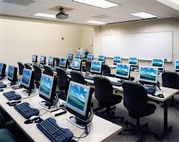 A 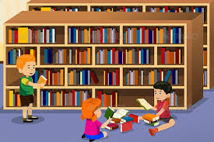 B
2. 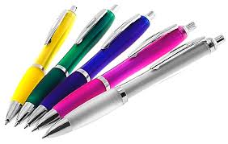 A 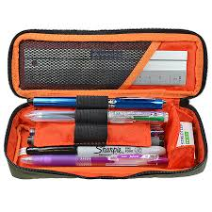 B
3.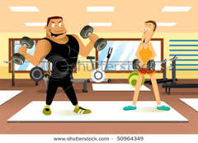 A 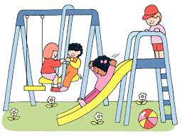 B
4. 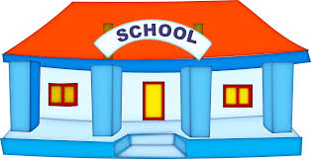 A 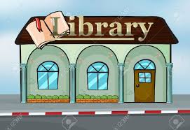 B

- Read and tick
1. My school is very big. | A. 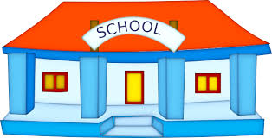 | B. 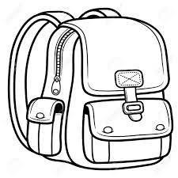
2. They are my notebooks. | A. | B. 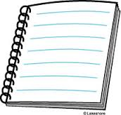
3. Are those your erasers?  Yes, they are. | 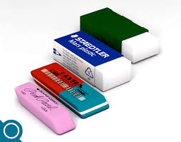  A. | 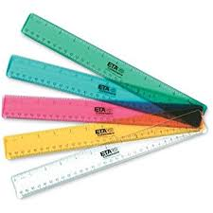  B.
4. I like singing. | A. 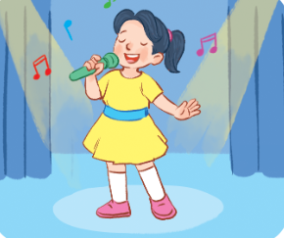 | 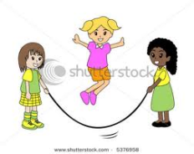  B.
- Look and write
Look at my school things. I have a school bag. It is brown. My books and notebooks are blue. My pencil case and eraser are orange. My pen and pencil are black. I like my school things very much.
1. A school bag is .
2. My books and notebooks are .
3. My pencil case and eraser .
4. My pen and pencil are .
- Let’s talk
1. Listen and repeat | 2. Point, ask and answer
3. Listen and comment | 4. Interview

Teacher 1 Teacher 2

GLOBAL SUCCESS
LEVEL 3- TERM 1- FINAL TEST
Answer key
- Listen and circle ( 4 questions )
- A
- B
- C
- A
- Listen and tick ( 4 questions )
- B
- A
- B
- A
- Read and tick ( 4 questions )
- A
- B
- A
- A
4.Look and write ( 4 questions )
- Brown
- Blue
- Orange
- Black
- Let’s talk ( Choose 4 questions below )
- Topic 1: Greetings
- Greet:
+ Teacher: Hello
+ Student: Hello/Hi teacher
- Name:
+ Teacher: What’s your name?
+Student: My name’s Nam. I’m Nam.
- Age:
+ Teacher: How old are you? ( Giving clues: Are you 7 or are you 8?)
+ Student: I’m 8 years old.
-Health:
+ Teacher: How are you?
+ Student: I’m fine, thank you
- Topic 2: Our school
- Teacher shows the pictures of the classroom, library, music room, … and asks:
+ Teacher: Is this our library?
+ Student: Yes, it is
- Let’s go to the library
- Student: Ok, let’s go
- Topic 3: School things+ Colour
- The teacher can prepare some school things
+ Teacher: Show a pencil and ask: Do you have a pencil?
+ Student: Yes, I do/ No I don’t
+ Teacher: What colour is it?
+ Student: It’s ( pencil’s colour)
-Do the same step with another school thing.

