PHUONG KY PRIMARY SCHOOL  Name:______________________.  Class : 4____ |  |  |  | THE FIRST TERM TEST  ENGLISH GRADE 4  School Year : 2022 - 2023  Time : 40 minutes  Date: ................
 | Teacher 1 |  |  |  | Teacher 2
 | Marks |  |  |  |  |  | Comments
 | Listening | Reading and writing | Speaking |  |  | Total
PART I. LISTENING(3.75 pts)
Task 1. Listen and tick . There is one example.(1.25 pts)
Example: | 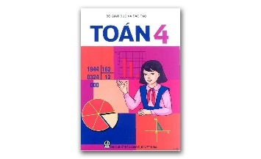 | 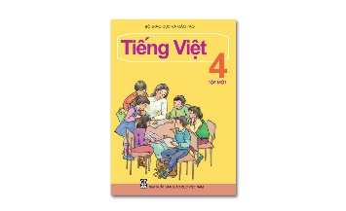
 | A. | B.

1. | A. B.
2. | A. B.
3. | A. B.
4. | A. B.
5. | A. B.

Task 2. Listen and tick or cross . There are two examples. (1.25 pts)
Examples: | 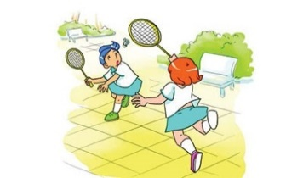 | 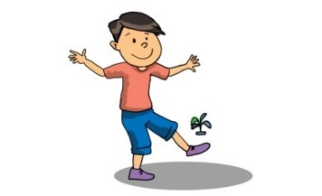
 | A. | B.

1. | 2. | 3.
4. | 5.
Task 3. Listen and circle the correct pictures. There is one example. (1.25 pts)
Example: | A. B C.

1. | A. | 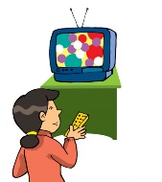 | B. |  | C. | 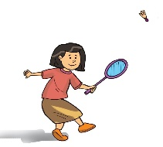
2. | A. | 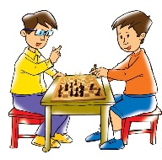 | B. | 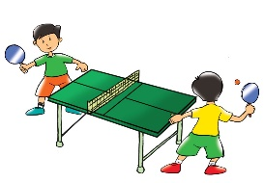 | C.
3. | A. | 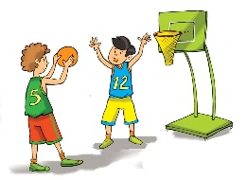 | B. | 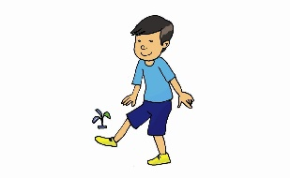 | C.
4. | A. |  | B. | 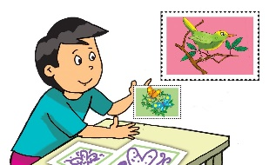 | C.
5. | A. |  | B. |  | C. | 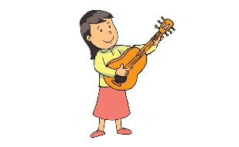

PART II. READING AND WRITING (4.25 pts)
Task 1. Look and write. There is one example. (1.5 pts)
Example: | siwmgmni → s w i m m i n g

1. igconok  →…………………. |  | 2. siinngg  → ………………….
3. sngkpipi  →…………………. |  | 4. ktngias  → ………………….
5. aidcnng  →…………………._ |  | 6. ingrade →…………………._
Task 2. Read and complete. There is one example (0). (1.25 pts)
A. watched | B. listened | C. watered
D. were | E. played | F. was
0. | My family _F_ at home yesterday.
1. | We ………………….the flowers in the morning.
2. | My brother ………………….TV in the afternoon.
3. | My sister and I ………………….chess with her friend in the living-room.
4. | My father and my mother………………….to music.
5. | We ………………….happy together at dinner in the evening.
Task 3. Read and complete the answers. (1.25 pts)
Hi. My name is Lan. I am from Cong Hoa Primary School. I like music very much. I like singing and playing the guitar. I can sing many songs, in Vietnamese and in English. I don't like drawing and taking photos. I have a best friend, Tony. He doesn't like drawing and taking photos. His hobby is collecting stamps. He has lots of stamps. He likes listening to my English songs, and I like looking at his beautiful stamps.
0. Her name is Lan.
1. She likes ………………….and playing the guitar.
2. She can ………………….many English songs.
3. She doesn't like ………………….photos.
4. Her friend likes ………………….stamps.
5. They are best ………………….
PART III. SPEAKING (2pts)
1. Listen and repeat | 2. Look and say
3. Answer the questions. | 4. Say goodbye.

